Lab 2(B)

At Premiere Products, there is a one-to-many relationship between representatives and customers. (Each representative is related to the many customers that he or she represents, and each customer is related to the one representative who represents the customer.) How is this relationship handled in a database system? It is handled by using common columns in the two tables. The RepNum column in the Rep table and the RepNum column in the Customer table are used to implement the relationship between reps and customers. Given a representative, you can use these columns to determine all the customers that he or she represents; given a customer, you can use these columns to find the rep who represents the customer.

How will Premiere Products store its data in a database? Figure below shows sample data for Premiere Products.

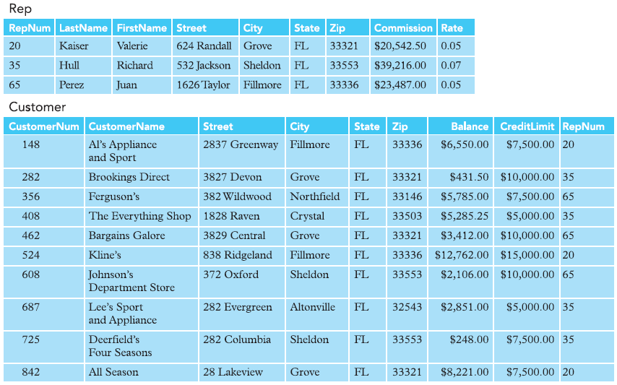

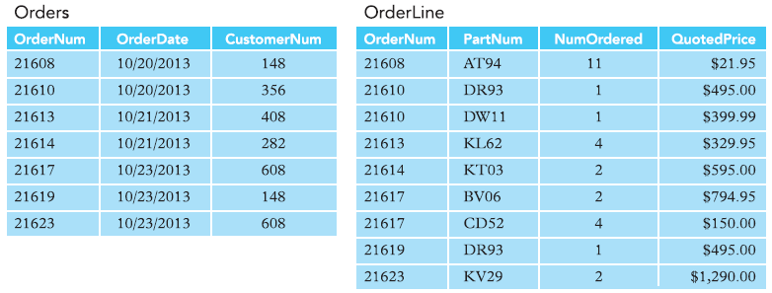

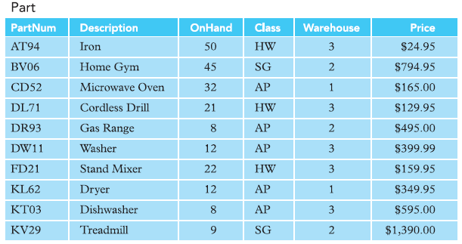

Answer each of the following questions using the Premiere Products data shown in the Figure below. No computer work is required.

1. List the names of all customers that have a credit limit less than $10,000.

148, 356, 408, 687, 725, 842

1. List the descriptions of all parts in item class AP and located in warehouse number 3.

Microwave oven, Gas Range, Washer, Dryer, Dishwasher

1. List the order numbers for orders placed by customer number 608 on October 23, 2013.

21617

1. List the part number, part description, and on-hand value (OnHand \* Price) for each part in item class SG.

* BV06 Home Gym 35,772.75.

1. List the name of each customer that placed an order for two different parts in the same order.
2. List the name of each customer that has a credit limit of $5,000 and is represented by Richard Hull.
3. Find the sum of the balances for all customers represented by Juan Perez.
4. For each order, list the order number, order date, customer number, and customer name.
5. For each order placed on October 21, 2013, list the order number, order date, customer number, and customer name.
6. For each order placed on October 20, 2013, list the order number and customer name, along with the name of the rep who represents the customer.